


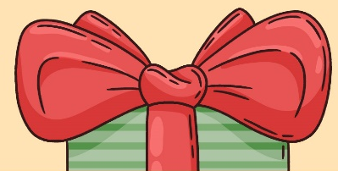
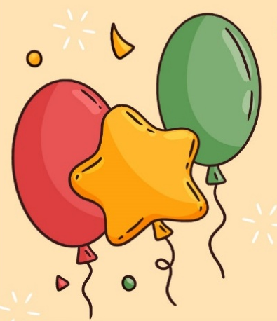
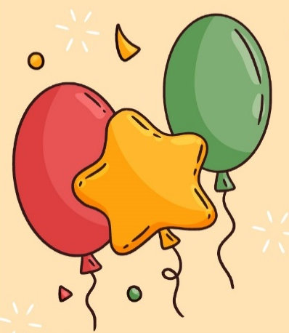



HAPPY NEW YEAR
You’re Warmly Invited to Celebrate the Arrival of a New Year!
Join us for an unforgettable night as we welcome 2026 with joy, excitement,
and sparkling moments.

Special Party

Wednesday, December 31st

Special Music Performance By
DJ JOHN DOE & DJ RICHARD ROE

Start At 9 PM – Ticket $15

Venue: [Your Venue Name or Address]
RSVP to ABC – (555) 555-555

