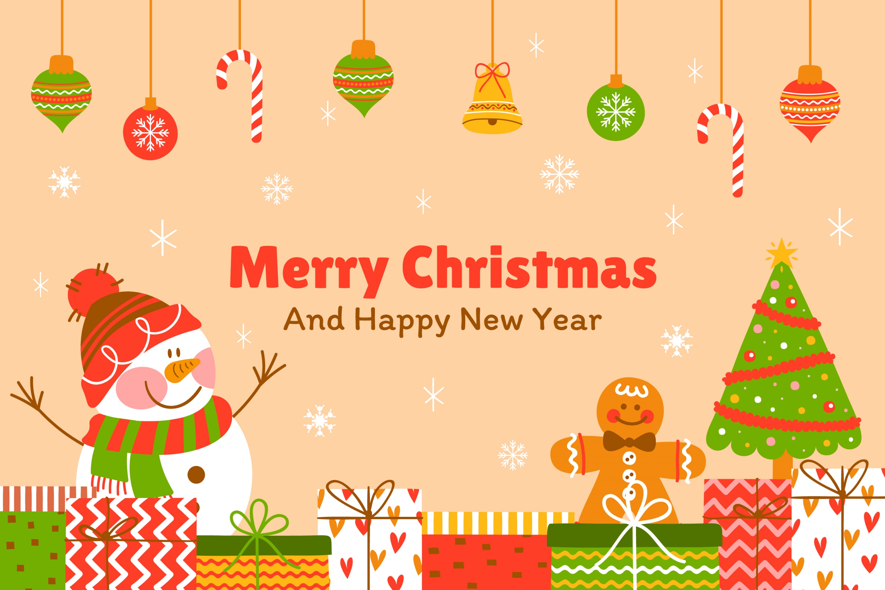
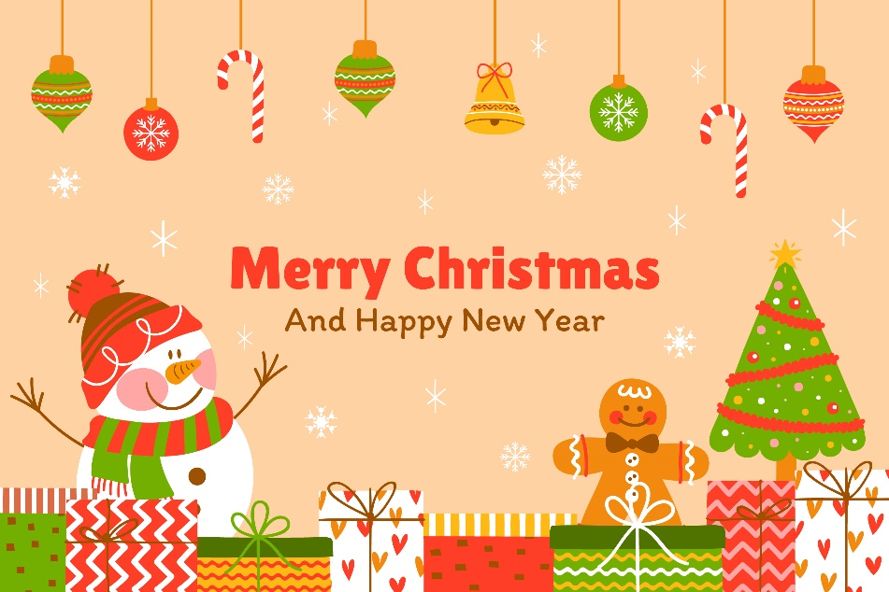
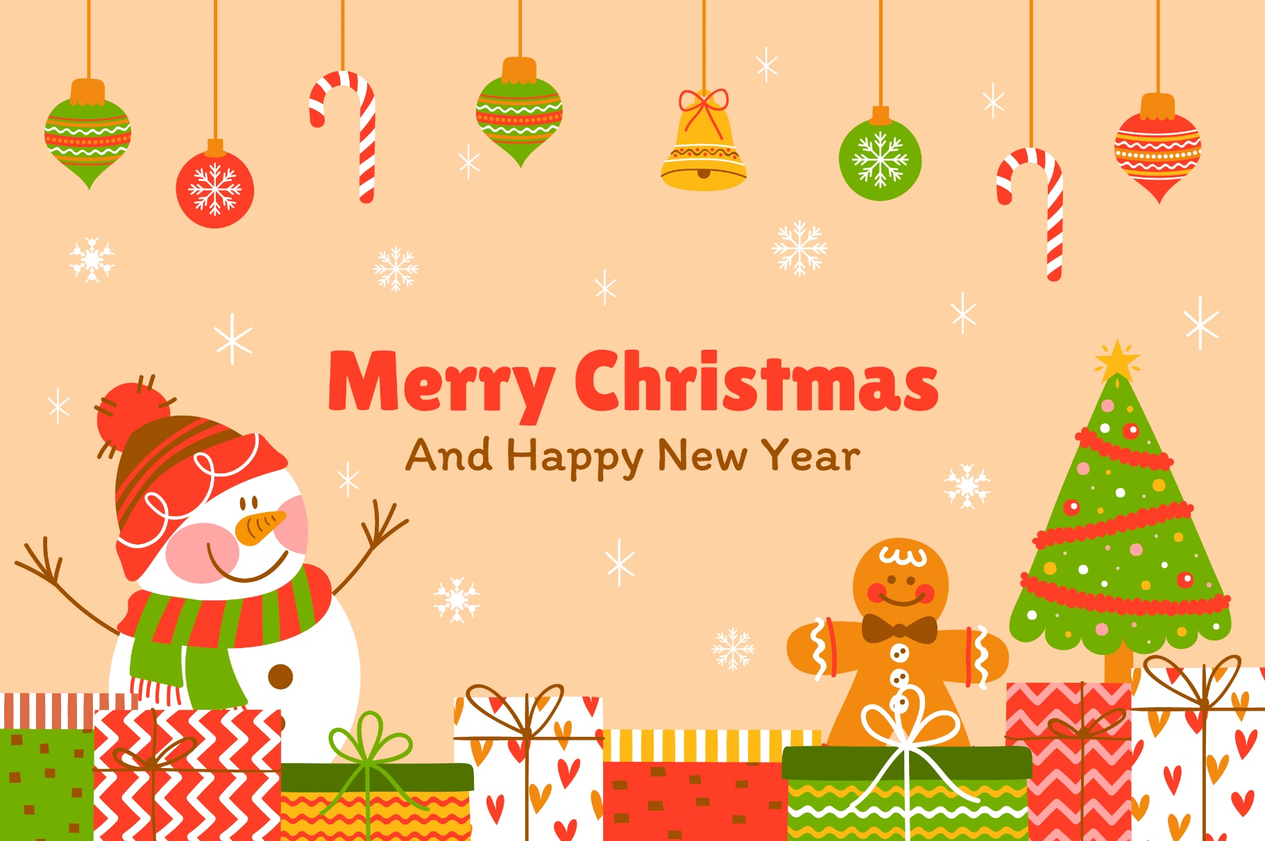


CHRISTMAS GIFT LIST

 | Recipient | Gift | Price | Notes
☐
☐
☐
☐
☐
☐
☐
☐
☐
☐
☐
☐
☐
☐
☐
☐
☐
☐

