

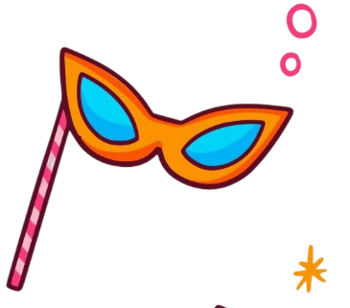
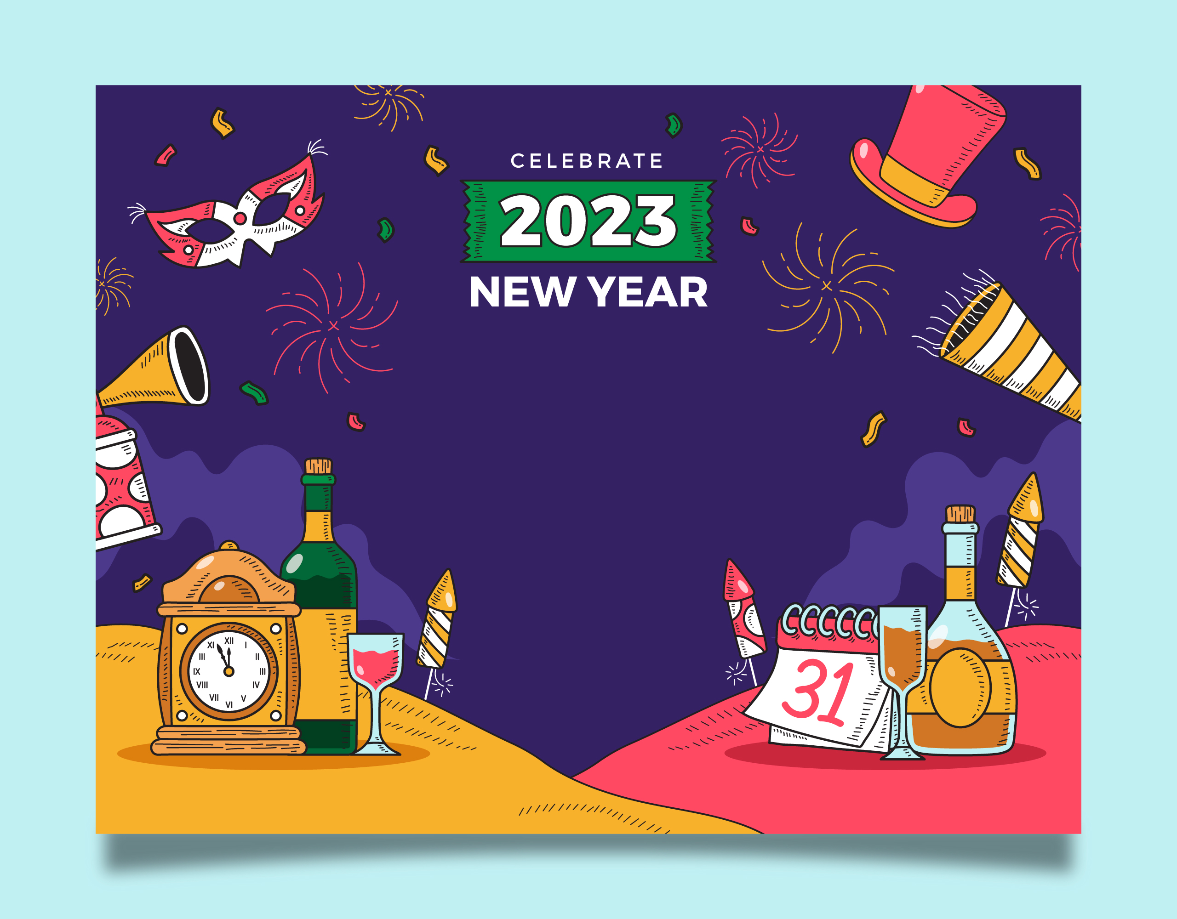
Let’s say goodbye to the old and welcome the new with a night full of excitement!
We’re hosting a New Year Party 2026, and you’re invited to join the celebration filled with high energy, great music, and unforgettable vibes.

DECEMBER 31 AT 9:00 PM

FREE PARKING | FREE DRINKS ALL NIGHT |
LADIES FREE BEFORE 10 PM

Dress Code: Glam & Sparkle
Venue: [Your Venue Name or Address]
RSVP to ABC – (555) 555-555

