





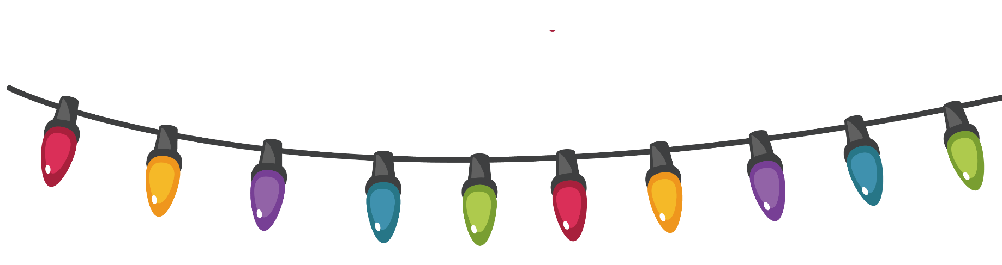
You’re Invited to Our Christmas Celebration!

Let’s gather for a joyful evening of laughter, music, and festive cheer.

Date: December 24, 2025
Time: 7:00 PM onwards
Venue: [Your Venue Name]

Delicious food, cheerful hearts, and Christmas magic await you!
Dress Code: Red, Red, or Gold

RSVP to ABC – (555) 555-555

