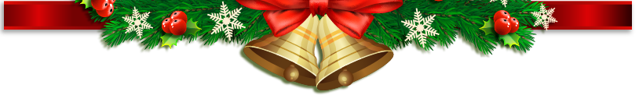


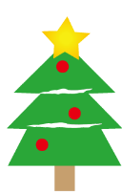
Christmas Gift List
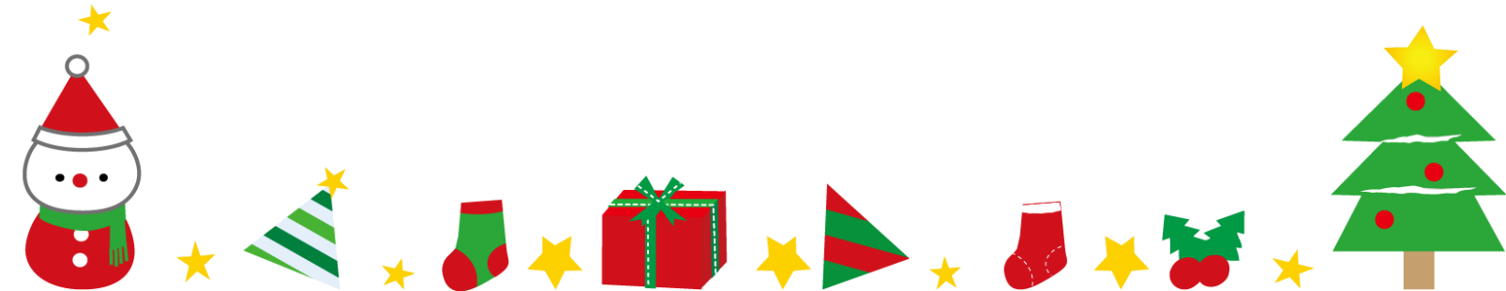
Recipient | Budgeted  Amount | Gift Description | Actual Cost | Purchased/ Made | Gift Wrapped | Additional Notes

