



\

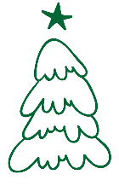

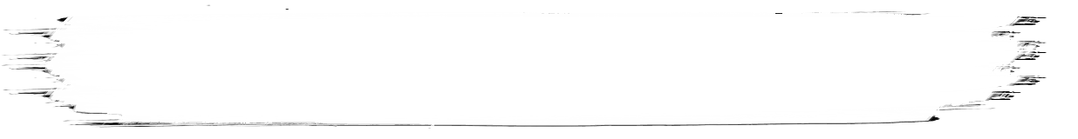


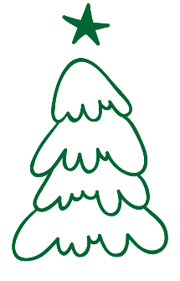
\pp
Party Invitation Flyer
You’re warmly invited to join us for an evening filled with joy, laughter, and festive cheer!
December 24, 2025, at 7:00 PM
Dress Code: Festive Attire
Venue: [Your Venue Name or Address]

Let’s celebrate the magic of Christmas together with music, food, and holiday fun!
RSVP to ABC – (555) 555-555

