 | PROFORMA - 10
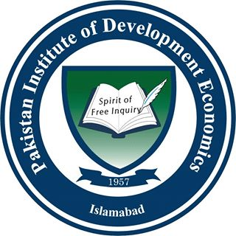 | Pakistan Institute of Development Economics, Islamabad | 
Teacher Evaluation Form
(To be filled by the student)
Course Title: ______________________________________________________________
Instructor Code: ________________________Semester___________________________
Department: _____________________________Degree___________________________
Use the scale to answer the following questions below
Scale: A: Strongly Agree B: Agree C: Uncertain D: Disagree E: Strongly Disagree
S.NO | Instructor:
 | The Instructor is prepared for each class | A | B | C | D | E
 | The Instructor demonstrates knowledge of the subject | A | B | C | D | E
 | The Instructor gives citations regarding current situations with reference to Pakistani context. | A | B | C | D | E
 | The Instructor communicates the subject matter effectively | A | B | C | D | E
 | The Instructor maintains an environment that is conducive to learning | A | B | C | D | E
 | The Instructor is punctual | A | B | C | D | E
 | Does the instructor provide useful feedback? | A | B | C | D | E
 | The Instructor is available to students outside the class time for tutoring, review work, or answer questions | A | B | C | D | E
 | The Instructor is fair and firm in discipline without being too strict | A | B | C | D | E
 | The instructor uses variety of appropriate assessment methods and instruments | A | B | C | D | E
 | The instructor ensures equitable participation in discussions | A | B | C | D | E
- T | The instructor presents difficult course material clearly | A | B | C | D | E
 | The instructor uses vocabulary and style appropriate to level of students | A | B | C | D | E

Additional Comments | Comment Box

