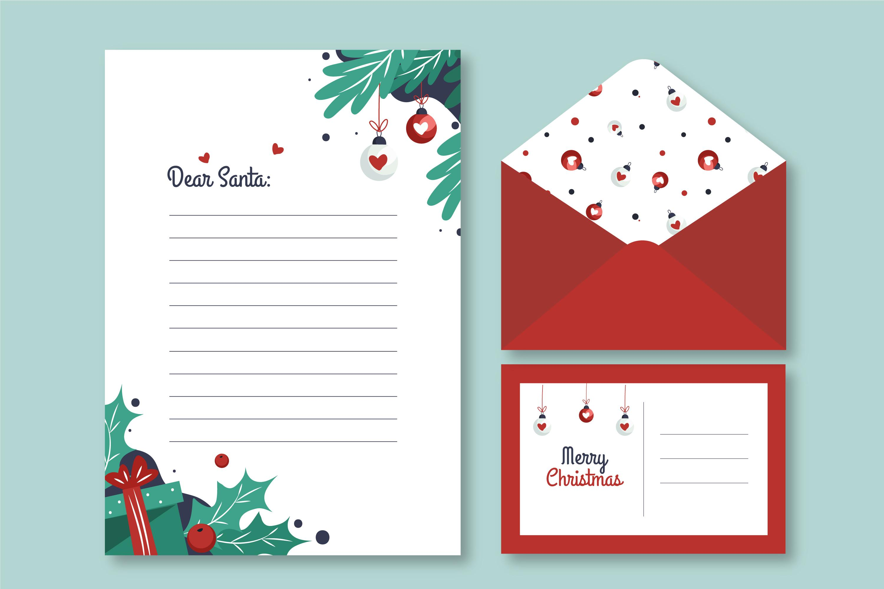
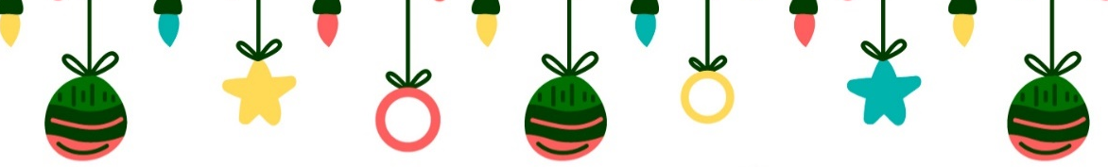
Christmas
Gift List


Gift Recipient | Relationship | Age | Gift Idea | Budget $ | Actual $
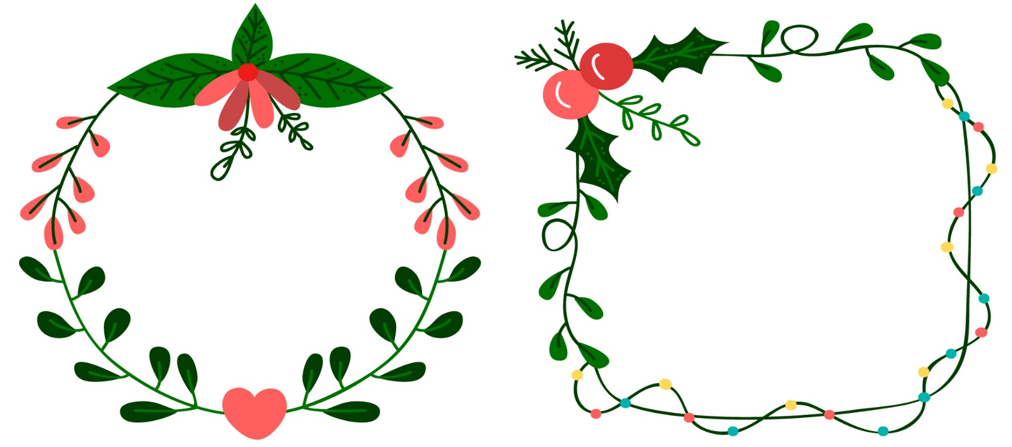
Notes
___________________________
___________________________
___________________________
___________________________
___________________________
___________________________

Notes
____________________
____________________
____________________
____________________

