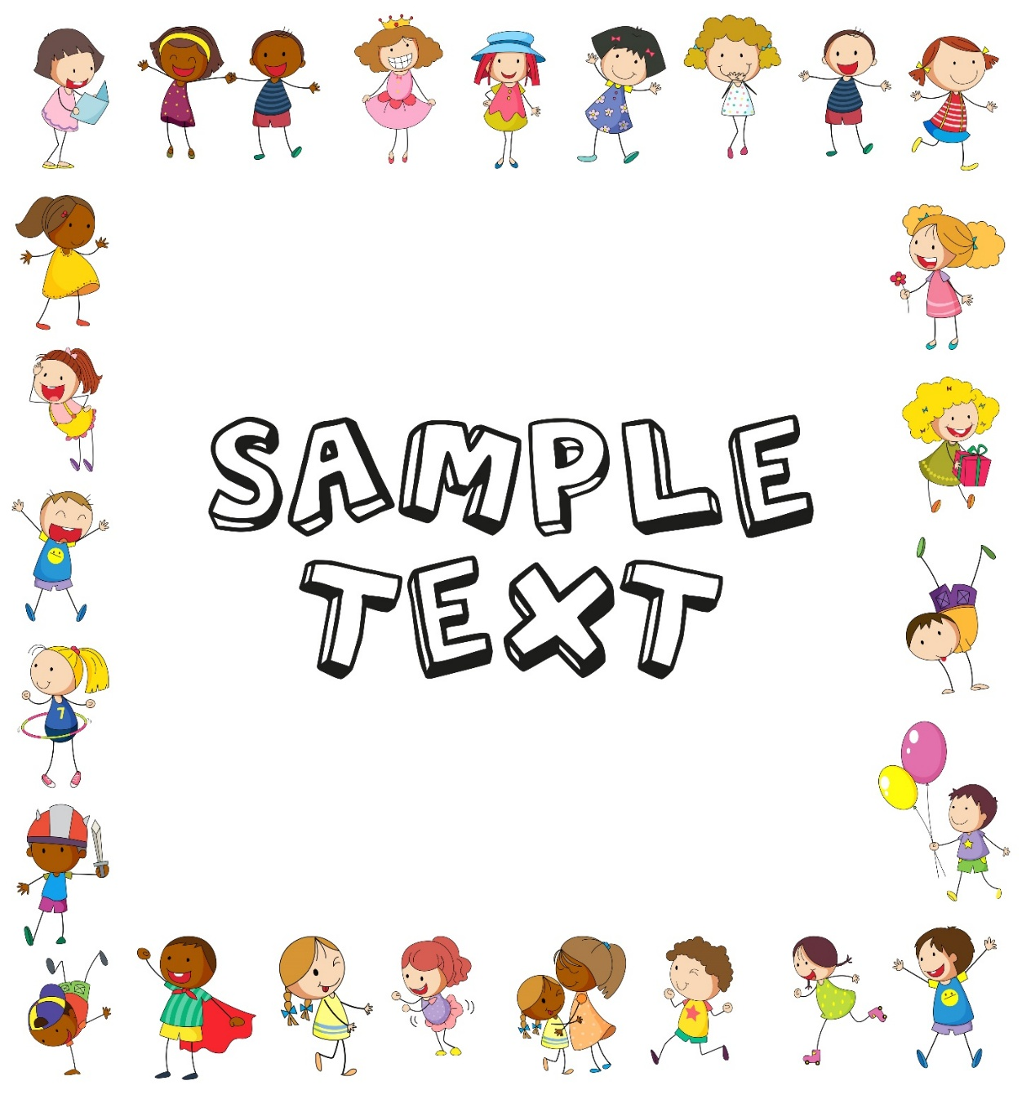

**Weekly To Do List**

|  |  |  |  |  |  |  |  |
| --- | --- | --- | --- | --- | --- | --- | --- |
| **Notes for the Week** | | | | **Meal Plans** | | | |
|  | | | |  | | | |
|  | | | | | | | |
| **Weekly Appointments** | | | | | | **Cleaning** | |
| **With** | | | **Time** | **Place** | |  | |
|  | | |  |  | |  | |
|  | | |  |  | |  | |
|  | | |  |  | |  | |
|  | | | | | | | |
| **Weekly To Do** | | | | | | | |
| **Monday** | **Tuesday** | **Wednesday** | | **Thursday** | **Friday** | | **Saturday** |
|  |  |  | |  |  | |  |