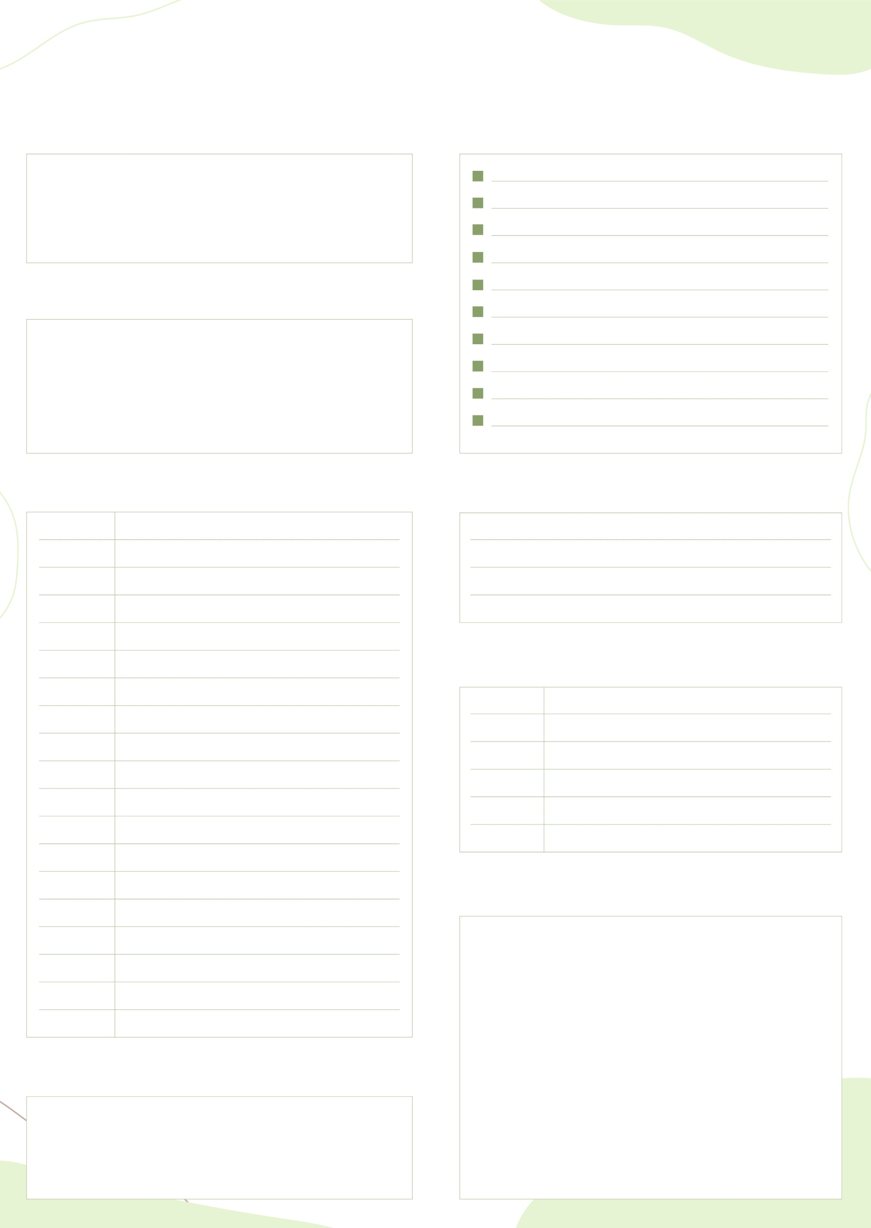

TO-DO LIST
GOAL
FOCUS
SCHEDULE
PERSONAL
NOTE
APPOINTMENT
PRIORITIES
TO DO

